SIMATS ENGINEERING
ASSESSMENT TOOL 1
NAME: M.PAVITHRAN
REG NO:192411014
COURSE NAME: INTERNET PROGRAMMING
COURSE CODE: CSA4308
COURSE OUTCOME COVERED

CO-1 : Develop well-structured, standards-compliant web pages using HTML/XHTML and
XML, and apply Internet protocols and HTTP communication mechanisms for web content
delivery. (L2)

1: Online Symposium Portal
A college is developing an online symposium registration portal. The following HTML
structure and HTTP interaction is observed:
&lt;form action=&quot;/register&quot; method=&quot;POST&quot;&gt;
&lt;input type=&quot;text&quot; name=&quot;name&quot;&gt;
&lt;input type=&quot;email&quot; name=&quot;email&quot;&gt;
&lt;button&gt;Submit&lt;/button&gt;
&lt;/form&gt;
When a student submits the form, the browser sends an HTTP request to the server, and the
server responds accordingly.
Questions:

- Identify appropriate HTML5 semantic elements missing in the structure.
Missing semantic elements:
- <header> – Displays the title or heading of the symposium portal.
- <main> – Contains the main content of the webpage.
- <section> – Groups the registration form.
- <article> – Can be used if the registration form is treated as independent content.
- <footer> – Displays copyright or contact information.
- <label> – Associates text labels with form fields for accessibility.

- Modify the structure to make it standards-compliant.
<!DOCTYPE html>
<html lang="en">
<head>
<meta charset="UTF-8">
<meta name="viewport" content="width=device-width, initial-scale=1.0">
<title>Online Symposium Registration</title>
</head>
<body>

<header>
<h1>Online Symposium Registration Portal</h1>
</header>

<main>
<section>
<h2>Student Registration Form</h2>

<form action="/register" method="POST">

<label for="name">Student Name:</label>
<input type="text"
id="name"
name="name"
required>

<br><br>

<label for="email">Email Address:</label>
<input type="email"
id="email"
name="email"
required>

<br><br>

<button type="submit">Submit</button>

</form>
</section>
</main>

<footer>
<p>&copy; 2026 ABC College Symposium Portal</p>
</footer>

</body>
</html>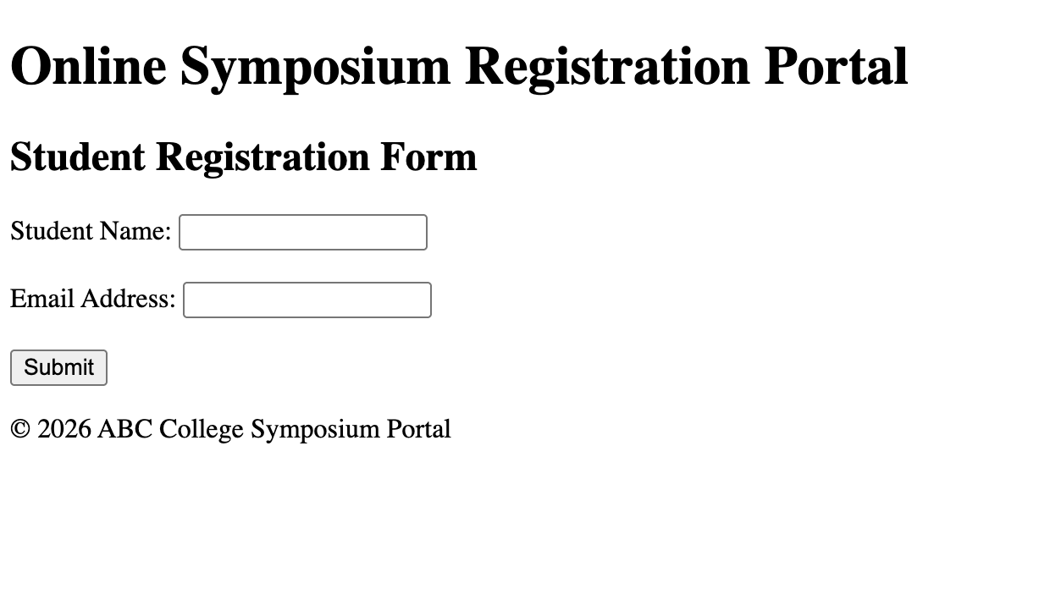

- Interpret the HTTP request generated during form submission.
When the student clicks the Submit button, the browser sends an HTTP POST request to the server because the form uses:
method="POST"
action="/register"

Interpretation
- POST – Sends form data securely in the request body.
- /register – URL where the registration request is sent.
- HTTP/1.1 – HTTP protocol version.
- Host – Server receiving the request.
- Content-Type – Indicates form data format.
- Content-Length – Size of submitted data.
- Request Body – Contains the student’s name and email.

- Analyze the HTTP response cycle from server to browser.
After receiving the request, the server processes the submitted data by validating it and storing it if valid. The server then returns an HTTP response containing a status code, headers, and optionally an HTML page or redirect instruction for the browser.[developer.mozilla]
For example, the server may send:
• 200 OK if registration succeeds and a confirmation page is returned.
• 400 Bad Request if the submitted data is invalid.
• 302 Found if the server redirects the student to a success page.
The browser receives this response, interprets the status and headers, and then displays the returned page or follows the redirect automatically.
- Suggest improvements for usability and accessibility.

Usability Improvements
- Add clear labels for all input fields.
- Use placeholder text to guide users.
- Display validation error messages.
- Add a Reset button if appropriate.
- Use responsive design for mobile devices.
- Display a success confirmation after submission.
- Group related fields using <fieldset> and <legend> if more inputs are added.

Accessibility Improvements
- Associate every input with a <label>.
- Use meaningful button text such as “Register Now”.
- Add required attributes for mandatory fields.
- Ensure keyboard navigation using the Tab key.
- Maintain sufficient color contrast for readability.
- Add ARIA attributes (if necessary) to improve support for screen readers.
- Use semantic HTML elements (header, main, section, footer) for better navigation by assistive technologies.
2: Cross-Browser Compatibility Issue

A company website shows inconsistent layout across browsers. The following HTML snippet
is used:
&lt;html&gt;
&lt;head&gt;
&lt;title&gt;Company&lt;/title&gt;
&lt;/head&gt;
&lt;body&gt;
&lt;div&gt;
&lt;h1&gt;Welcome
&lt;p&gt;About us
&lt;/div&gt;
&lt;/body&gt;
&lt;/html&gt;
Questions:

  - Identify improper nesting and missing closing tags.
<html>
<head>
<title>Company</title>
</head>
<body>
<div>
<h1>Welcome
<p>About us
</div>
</body>
</html>

Errors
- <h1> tag is not closed (</h1> is missing).
- <p> tag is not closed (</p> is missing).
- The <div> contains improperly nested elements.
- The document is missing the <!DOCTYPE html> declaration.
- The <html> tag should include the language attribute (lang="en").
- The <head> section should include the character encoding (<meta charset="UTF-8">) and viewport meta tag for responsive design.

  - Analyze how different browsers may interpret this structure.
Since the HTML is not properly written, different browsers may automatically correct the errors in different ways.

Browser Interpretation
- Google Chrome (Blink Engine):
  - Automatically inserts the missing closing tags.
  - Usually displays the page correctly.
- Mozilla Firefox (Gecko Engine):
  - Attempts to repair the HTML structure.
  - Layout may slightly differ from Chrome.
- Microsoft Edge (Blink Engine):
  - Similar behavior to Chrome.
  - Automatically fixes missing tags.
- Safari (WebKit Engine):
  - Repairs invalid HTML.
  - Small differences in spacing or rendering may occur.

Result
Because browsers use different HTML parsing algorithms, invalid HTML can produce:
- Different layouts
- Different spacing
- Inconsistent font rendering
- Unexpected CSS behavior
- Poor accessibility
Using valid HTML ensures consistent rendering across all browsers.

3.Identify missing semantic elements (e.g., header, section).
Missing semantic elements:
- <header> – Contains the company title.
- <main> – Contains the primary page content.
- <section> – Groups the “About Us” information.
- <footer> – Displays copyright or contact information.
- <nav> – If navigation links are added later.
4.Provide a corrected W3C-compliant HTML structure.
<!DOCTYPE html>
<html lang="en">

<head>
<meta charset="UTF-8">
<meta name="viewport" content="width=device-width, initial-scale=1.0">
<title>Company</title>
</head>

<body>

<header>
<h1>Welcome</h1>
</header>

<main>
<section>
<p>About us</p>
</section>
</main>

<footer>
<p>&copy; 2026 Company. All Rights Reserved.</p>
</footer>

</body>
</html>
5.Suggest techniques to ensure cross-browser compatibility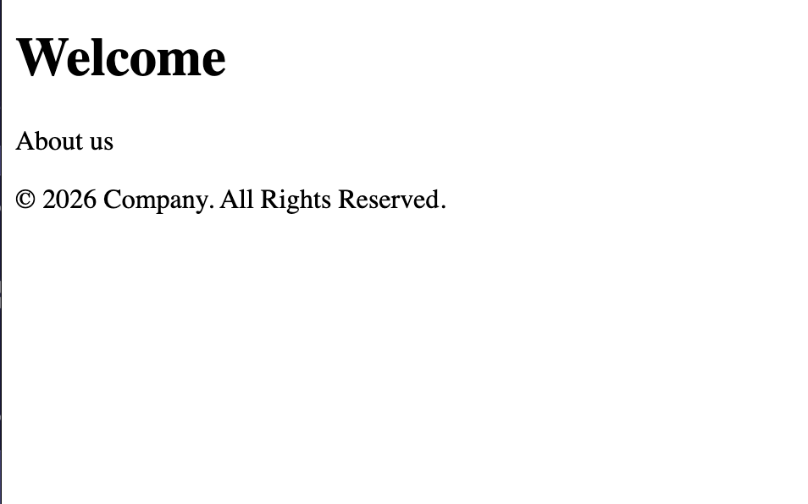

5.Suggest techniques to ensure cross-browser compatibility

a) Use Valid HTML
- Follow W3C HTML5 standards.
- Properly close all tags.
- Validate code using the W3C HTML Validator.

b) Use Semantic HTML
- Replace generic <div> elements with semantic tags like <header>, <main>, <section>, and <footer>.

c) Use CSS Reset or Normalize
- Apply a CSS Reset or Normalize.css to reduce default style differences between browsers.

d) Test on Multiple Browsers
- Check the website in:
  - Google Chrome
  - Mozilla Firefox
  - Microsoft Edge
  - Safari

e) Use Responsive Design
- Include the viewport meta tag.
- Use flexible layouts (Flexbox or CSS Grid).
- Use relative units such as %, em, and rem.

3: Form Submission Failure
A web application fails to send form data to the server. The following configuration is
observed:
&lt;form action=&quot;/submit&quot; method=&quot;GET&quot;&gt;
&lt;input type=&quot;text&quot; name=&quot;username&quot;&gt;
&lt;input type=&quot;password&quot; name=&quot;password&quot;&gt;
&lt;button type=&quot;button&quot;&gt;Login&lt;/button&gt;
&lt;/form&gt;
Questions:
- Identify issues in the form configuration.

Issues
- Button type is incorrect
  - The button uses type="button".
  - This does not submit the form.
  - It should be type="submit".
- GET method is used
  - GET sends data in the URL.
  - It is not suitable for sensitive information like passwords.
- No labels
  - The input fields do not have <label> elements, reducing accessibility.
- No validation
  - The fields are not marked as required.
- Password exposed
  - With the GET method, the password appears in the URL, making it insecure.
- Analyze why the HTTP request is not triggered.

The HTTP request is not triggered because:
- The button is defined as:
<button type="button">Login</button>
- A button with type="button" performs no default action.
- It only works if JavaScript is written to handle the click event.
- Since no JavaScript is provided, clicking Login does nothing.

- Interpret the role of GET method in this scenario.

The form uses:
method="GET"

Role of GET
- Sends form data through the URL as query parameters.
- Used mainly to retrieve information from a server.
- Data is visible in the browser’s address bar.
- Data can be bookmarked and cached.
- Limited amount of data can be sent.

- Propose a corrected implementation.

<!DOCTYPE html>
<html lang="en">

<head>
<meta charset="UTF-8">
<meta name="viewport" content="width=device-width, initial-scale=1.0">
<title>Login Form</title>
</head>

<body>

<h2>Student Login</h2>

<form action="/submit" method="POST">

<label for="username">Username:</label>
<input type="text"
id="username"
name="username"
required>

<br><br>

<label for="password">Password:</label>
<input type="password"
id="password"
name="password"
required>

<br><br>

<button type="submit">Login</button>

</form>

</body>
</html>

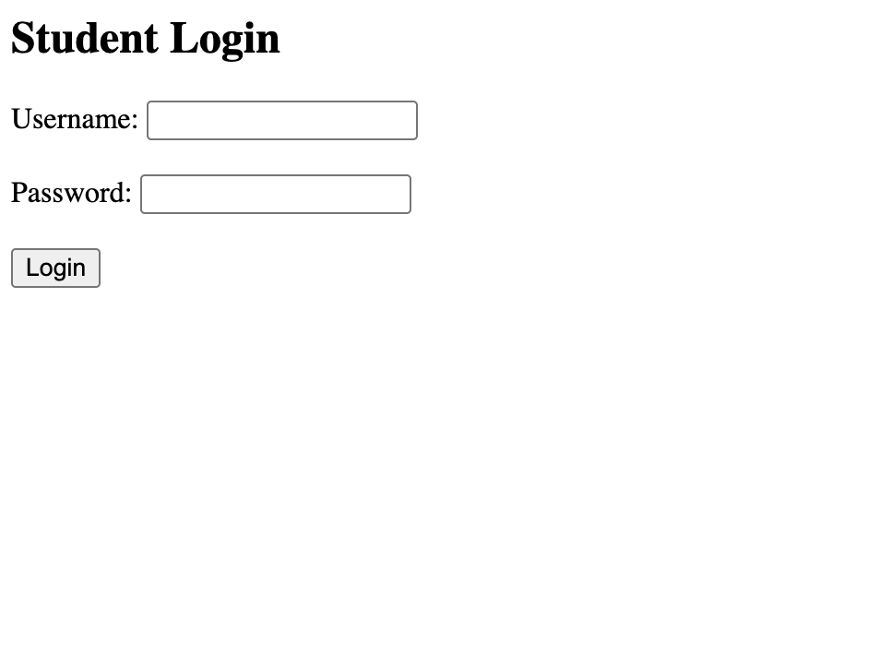

- Suggest improvements for secure data transmission.

a) Use POST Method
- Send sensitive information in the request body instead of the URL.

b) Use HTTPS
- Encrypt communication between the browser and the server using SSL/TLS.

c) Validate User Input
- Perform both client-side and server-side validation to prevent invalid or malicious data.

d) Hash Passwords
- Store passwords using secure hashing algorithms such as bcrypt, Argon2, or PBKDF2 instead of plain text.

e) Enable Authentication Security
- Use secure session management and authentication tokens where appropriate.

